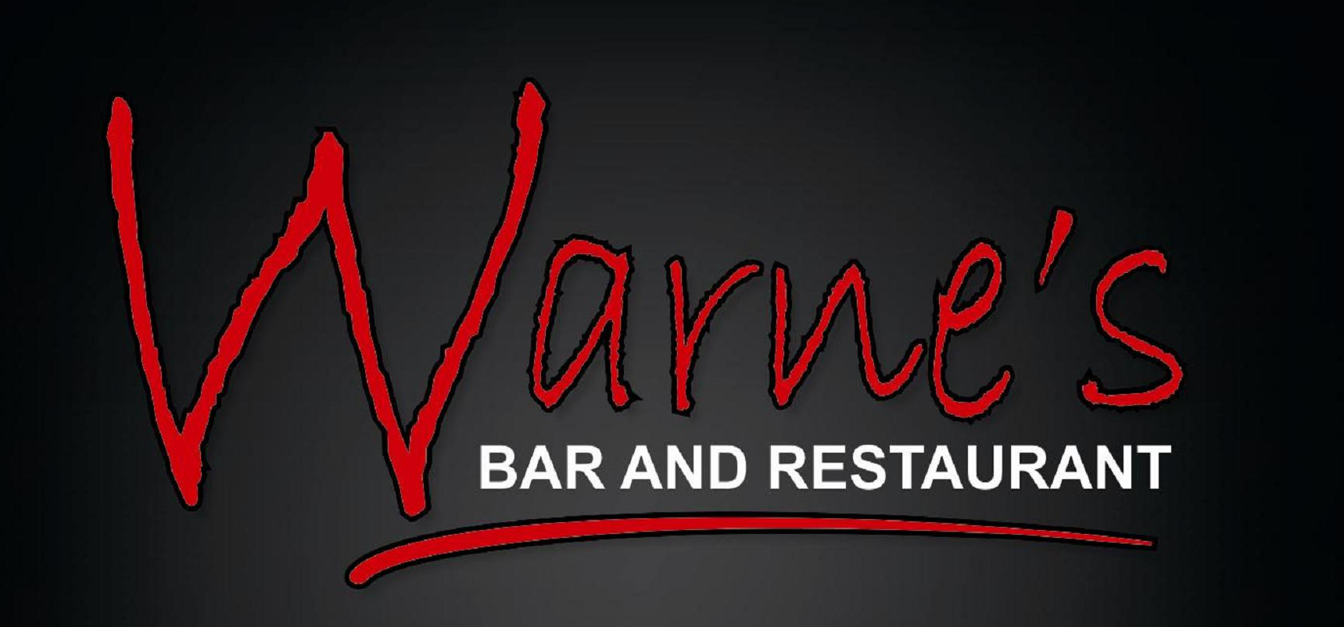

Pre Order Sheet

Party Name: Party Date: Tel no:
Total Guests: Email:

Name | Soup | Chicken  Liver | Brie | Smoked Salmon | Prawn & Pork | Roast  Turkey | Beef | Hake | Nut Loaf | Xmas Pud | Apple  Rice  Balls | Crème Brulee | Ice Cream | Cheese

All pre orders must be emailed or posted to us no later than 1 week prior to your party.
A deposit of £10 per head is required no later than 1 week prior to your party.
All deposits are non refundable

Warne’s Bar & Restaurant, Polmorla Mews
Wadebridge, Cornwall, PL27 7LZ
01208 814332
www.warnesbarandrestaurant.co.uk
bookings@warnesbarandrestaurant.co.uk

